

**G2-FOODWHALE**

**Software Requirement Specification**

– Hanoi, November 2021 –

**Record of changeS**

| **Date** | **A* M, D** | **In charge** | **Change Description** |
| --- | --- | --- | --- |
| 29/11/2021 | A | Ha | Create FoodWhale Software Requirement Specification |
| 29/11/2021 | A | Quoc | Write Introduction about FoodWhale System, list all Non- Screen Functions and their descriptions |
| 29/11/2021 | A | Minh | Write user authorization, order the roles of Screens |
| 29/11/2021 | A | Nghia | Create Screen Flow for Customer, Staff and Admin |
| 29/11/2021 | A | Ha | Create new Figure for Introduction, write Screen Details |
| 01/12/2021 | A | Quoc | Write Functional Requirements for vertical prototype |
| 01/12/2021 | M | Quoc | Modify Context Diagram |
| 01/12/2021 | M | Nghia | Update screen flow |
| 02/12/2021 | M | Quoc | Modify Screen Details and User Authorization |
| 02/12/2021 | A | HoangAnh | Add Edit Profile |
| 02/12/2021 | A | Quoc | Write functional requirement for Reset Password |
| 02/12/2021 | A | Ha | Write functional requirements for OrderManagement and CustomerManagement, Recipe Management |
| 02/12/2021 | A | Minh | Update User Authorization |
| 02/12/2021 | A | Nghia | Write View Recipe and View Ingredient in functional requirement |
| 07/12/2021 | A | HoangAnh | Add To Cart |
| 07/12/2021 | A | Nghia | Write View Recipe Detail and View Ingredient Detail |
| 07/12/2021 | A | Ha | Write Ingredient and Category Management |
| 07/12/2021 | A | Quoc | Write Post Recipe and View liked Recipe |
| 10/12/2021 | A | Quoc | Write User Order History and Favourite Recipe management |
| 10/12/2021 | A | Nghia | Cart Detail |
| 10/12/2021 | A | Ha | Write order detail for Order Management, Recipe Ingredient Link |
| 10/12/2021 | A | Hoanganh | Write Change Password, ContactPage |
| 10/12/2021 | A | Minh | Write Error page, create share button and comment for recipes |

*A - Added M - Modified D - Deleted

**Table of Contents**

I. Overview 4

1. Introduction 4

2. System Functions 4

II. Functional Requirements 11

1. Home page 11

2. Login Screen 12

3. User Register 13

4. User Profile 14

5. Admin Dashboard 15

6. User Management 17

7. Reset Password 19

8. Order Management 21

9. Customer Management 23

10. Recipe Management 25

11. View Recipe 26

12. View Ingredient 28

13. Add to Cart 30

14. Post Recipe 31

15. View Liked Recipe 32

16. View Recipe Detail 33

17. View Ingredient Detail 34

18. Ingredient Management 35

19. Category Management 36

# I. Overview

## 1. Introduction

The 4.0 revolution is approaching, that’s why information technology has been playing a huge role today. Nowadays, when we want to cook a new dish, we can easily look for the recipes on the Internet, but when it comes to finding the ingredients many will struggle. FoodWhale is aware of this problem, and the FoodWhale system will support users to buy ingredients in addition to the recipes.

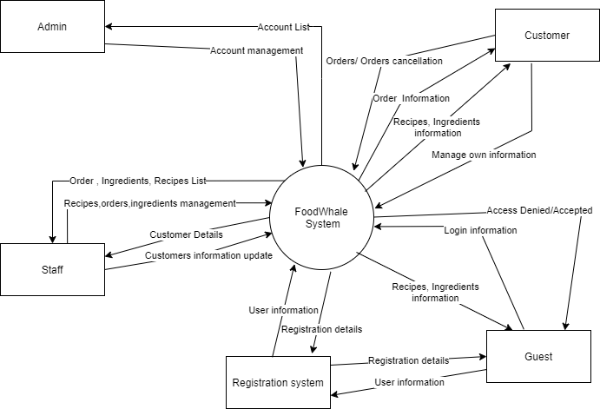

## 2. System Functions

#### a. Screen Flow

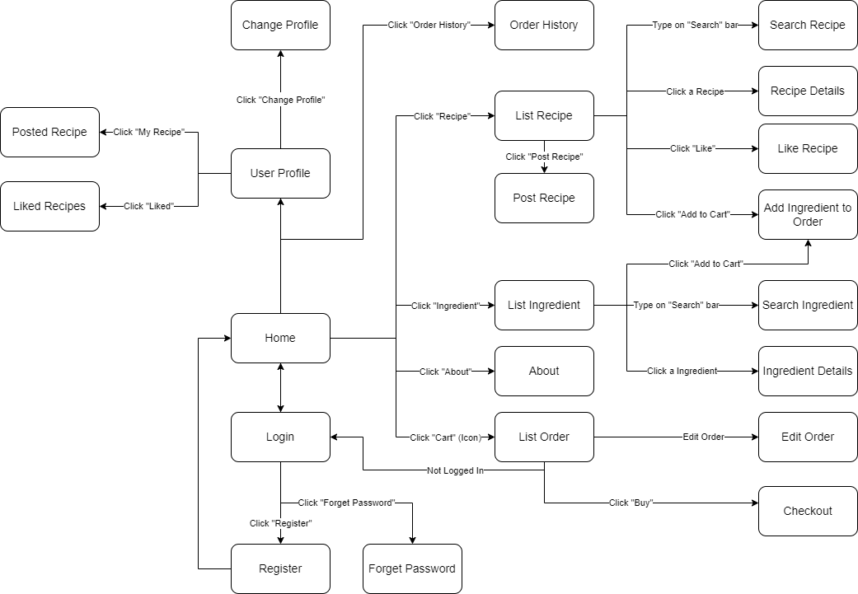

Figure 1-1: Screen Flow for User

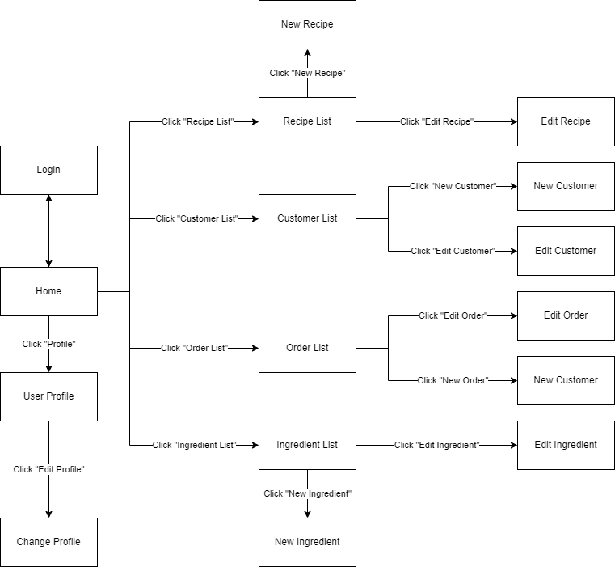

Figure 1-2: Screen Flow for Staff

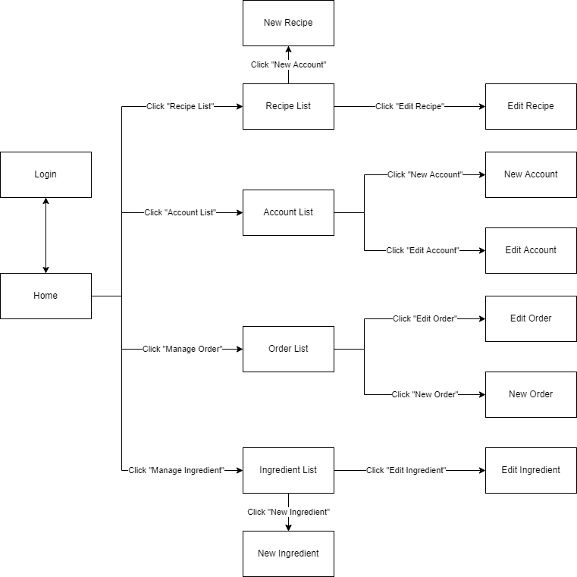

Figure 1-3: Screen Flow for Admin

#### b. Screen Details

| **#** | **Feature** | **Screen** | **Description** |
| --- | --- | --- | --- |
| 1 | Home Page | Home Page | Show homepage |
| 2 | Login | Login | User Login to the System |
| 3 | Register | Register | User Register User Register for an account |
| 4 | Forget Password | Forget Password | Send a verification code through Email for user to reset password |
| 5 | Search & Filter Recipe | Recipe List | Search for a Recipe by name or filter it by category |
| 6 | Post Recipe | Recipe List | Create and post new Recipe |
| 7 | View Recipe Detail | Recipe Details | Display detail information of Recipe |
| 8 | Like Recipe | Recipe Details | Raise the like of the Recipe and add it to your liked list |
| 9 | Add to Cart | Recipe Details | Add all the ingredients of that Recipe to Cart |
| 10 | Search & Filter Ingredient | List Ingredient | Search for an Ingredient by name or filter it by category |
| 11 | View Ingredient Detail | Ingredient Details | Display detail information of Ingredient |
| 12 | Add to Cart | Ingredient Details | Add Ingredient to Cart |
| 13 | List Order | List Order | Customer views list of their order |
| 14 | Edit Order | List Order | Customer edit their Order |
| 15 | User Profile | User Profile | User views information about his account |
| 16 | Edit Profile | User Profile | User edit their information |
| 17 | Posted Recipe | My Recipe | Customer views their posted recipe |
| 18 | Liked | Liked Recipe | Customer views their liked recipe |
| 19 | Order History | Order History | Customer views their old Order |
| 20 | Manage Recipe | Manage Recipe | User views list of all Recipe in database and can create a new recipe by clicking on “Add new recipe” |
| 21 | Recipe Details | Recipe Details | User views detail information of a Recipe and can edit or delete it |
| 22 | Manage Ingredient | Manage Ingredient | User views list of all Ingredient in database and can click on “Add new Ingredient” to create new ingredient anh update to database |
| 23 | Ingredient Details | Ingredient Details | User views detail information of an Ingredient and can edit or delete it |
| 24 | Manage Customer | Customer List | User views list of all Customers in database and can click on “Add new customer” to create a new customer. |
| 25 | Customer Details | Customer Details | User views detail information of a Customer except for Role , and can edit or delete customer |
| 26 | Manage Order | Order List | User views list of all Order in database |
| 27 | Order Details | OrderDetails | User views detail information of an Order |
| 28 | Manage Account | Account List | User views list of all Accounts loaded from database , and can click on add new account button to create a new account |
| 29 | Account Details | Account Details | Admin views detail information of an Account and can edit or delete it |
| 30 | Error | Error | Announce that the website users are trying to reach couldn’t be found on the server |

#### c. User Authorization

| **Screen** | **Guest** | **Customer** | **Admin** | **Staff** |
| --- | --- | --- | --- | --- |
| Home Page | X | X | X | X |
| Login | X | X | X | X |
| Register | X | X | X | X |
| Forget password | X | X | X | X |
| Recipe List | X | X | X | X |
| Post Recipe |  | X | X | X |
| Recipe Details | X | X | X | X |
| Like Recipe |  | X |  |  |
| Cart |  | X |  |  |
| Ingredient List | X | X | X | X |
| Ingredient Details | X | X | X | X |
| Order List |  | X |  |  |
| Edit order |  | X |  |  |
| User Profile |  | X | X | X |
| Edit profile |  | X | X | X |
| Posted Recipe |  |  | X | X |
| Liked Recipe |  | X |  |  |
| Order History |  | X |  |  |
| Manage recipe |  |  | X | X |
| Recipe details |  |  | X | X |
| Manage ingredients |  |  | X | X |
| Ingredients details |  |  | X | X |
| Manage customers |  |  | X |  |
| Customer details |  |  | X |  |
| Manage account |  |  |  | X |
| Account details |  |  |  | X |
| Manage orders |  |  | X | X |
| Order details |  |  | X | X |
| Error | X | X | X | X |

In which:

* Guest: User who has not yet logged in to the site
* Customer: User who has an account and has logged in
* Staff: Access and manage customer, order, recipes and ingredients
* Admin: People who manage the system

#### d. Non-Screen Functions

| **#** | **Feature** | **System Function** | **Description** |
| --- | --- | --- | --- |
| 1 | Common | User Authorization | Implementation of authorization mechanism in the system, including the specify the role of logged-in user, his/her authorized page links (building the displayed menu items (in the front end) and preventing unauthorized access via enter the links directly) |

# II. Functional Requirements

## 1. Home page

### When user has not logged in

* Function trigger: When a user accesses the website.
* Function description: show sliders ,hot posts, featured services and static contact links.
* Screen Layout:

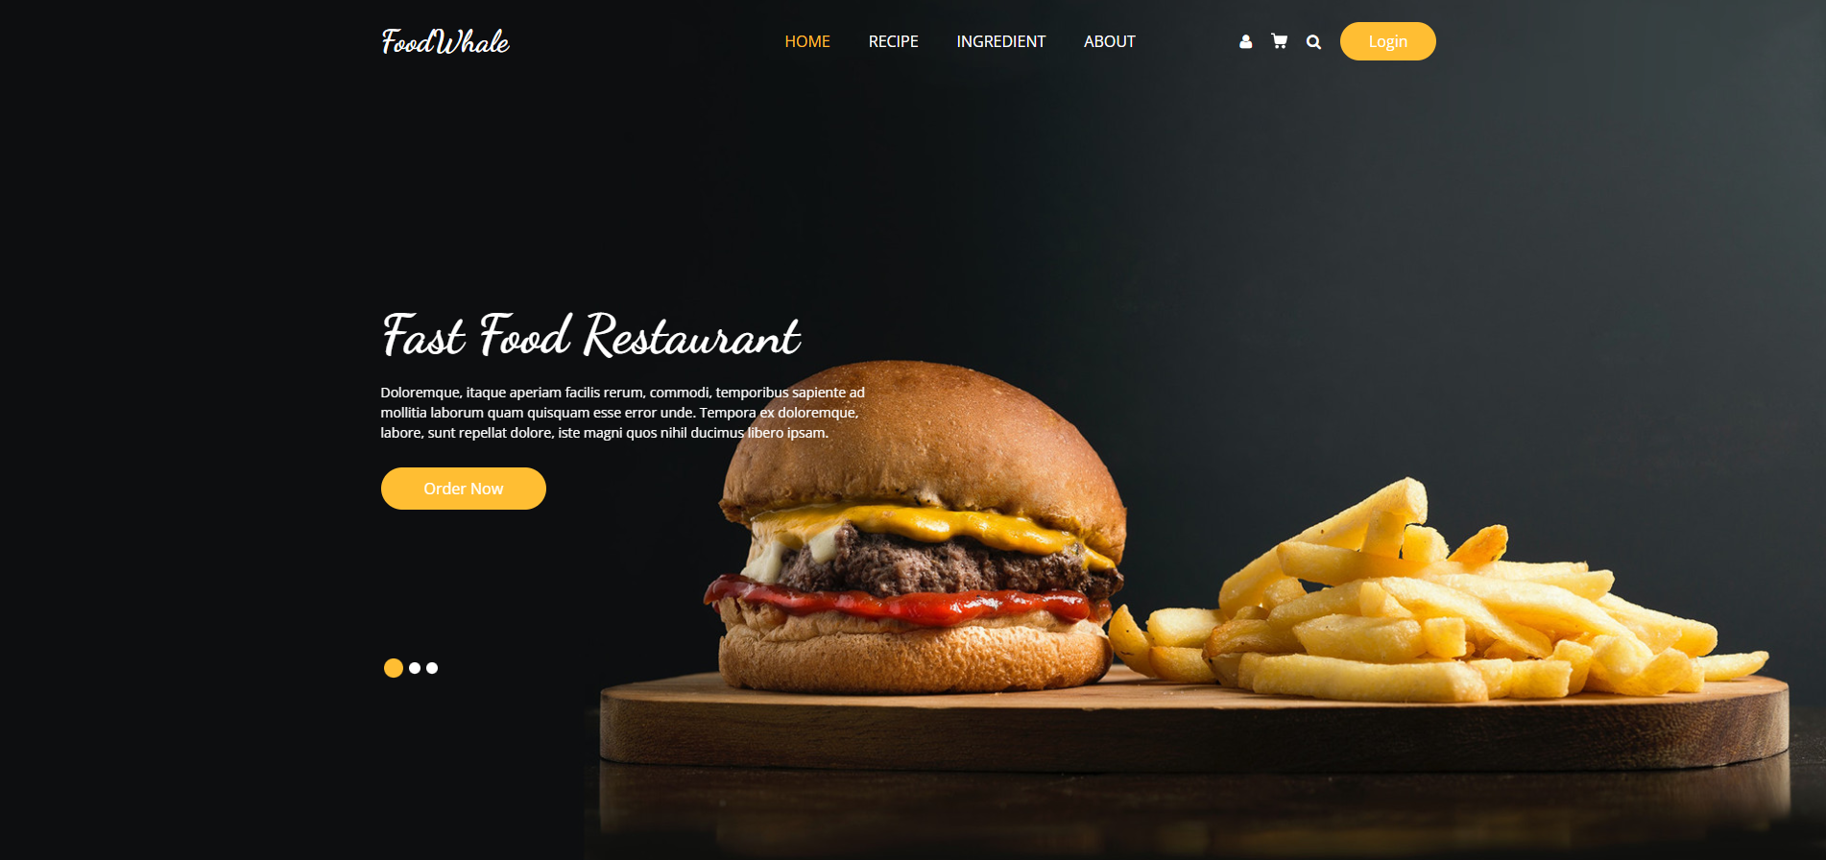  
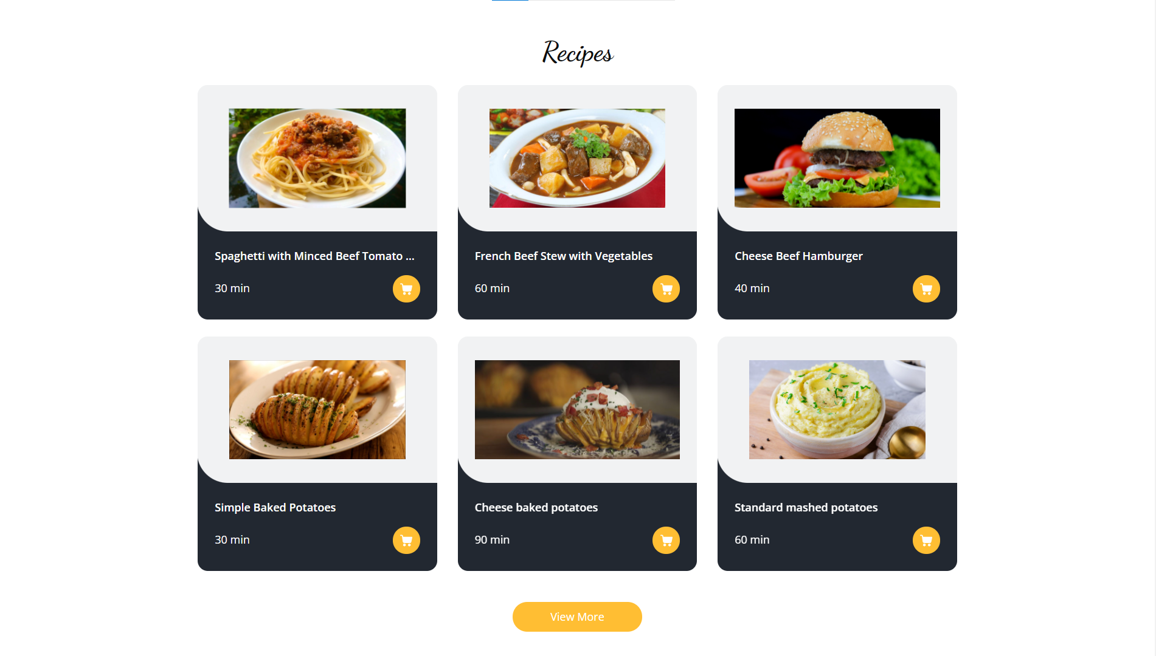

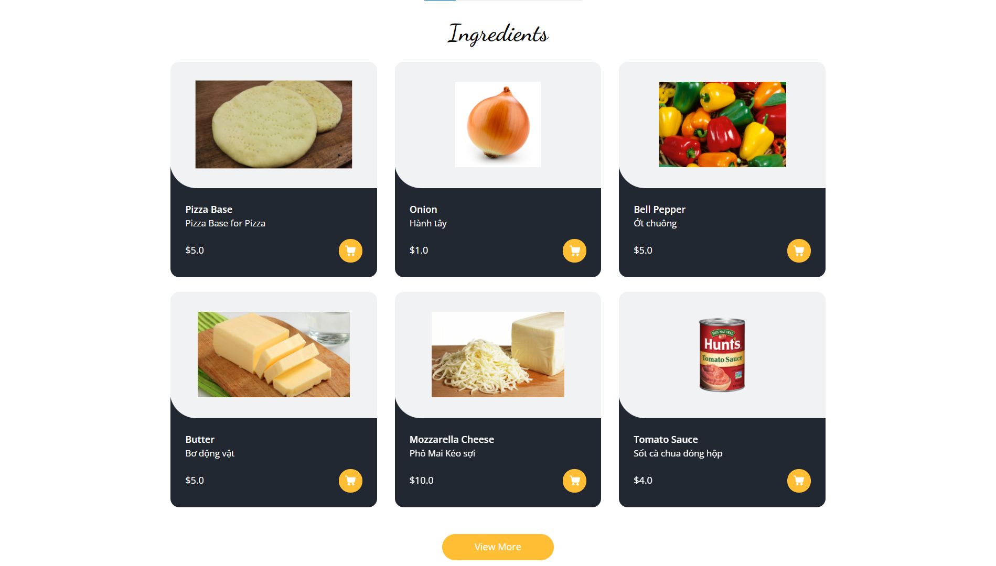

* Function details: Users can see the Recipes list , detailed information about the recipes , view ingredients list, and users can login by clicking on the login button.

### When user has logged in

* Function trigger: Homepage → Login as Customer
* Function description: show sliders ,hot posts, featured services and static contact links.
* Screen Layout:

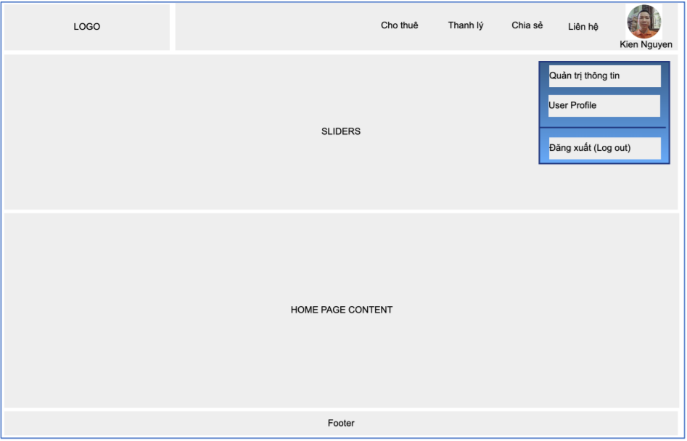

* Function details : Users can see recipes , ingredients list and can add ingredients to cart and create new orders for the ingredients

## 2. Login Screen

* Function trigger : Home page → Login
* Function description : Its purpose is to login as a user so that users can use it to get the most out of it and every activity of the user can be recorded and authenticate the user to give him/her to access authorized features later on
* Screen Layout :

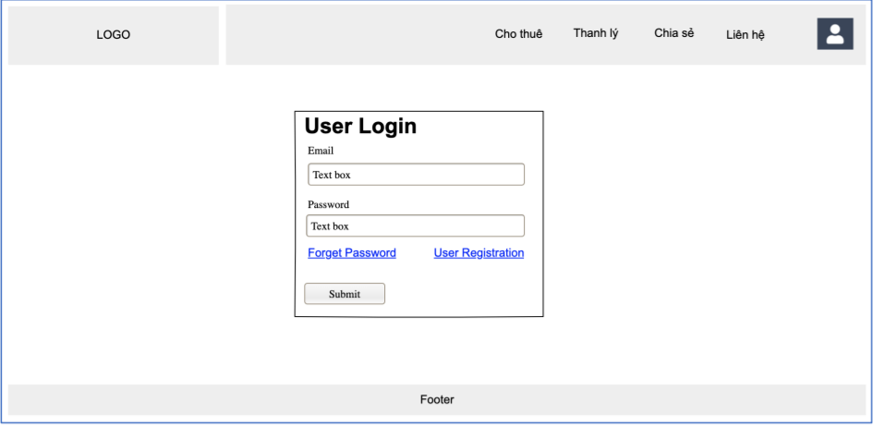

* Function details : Allows the user to enter username and password to login. On this page, there are also options for users to register a new account or reset the password in case she or he forgets it.

## 3. User Register

* Function trigger : Homepage-->Login-->User Register
* Function description : Its purpose is to register as a user in the system so that users can use it to get the most out of it and every activity of the user can be recorded.
* Screen Layout:

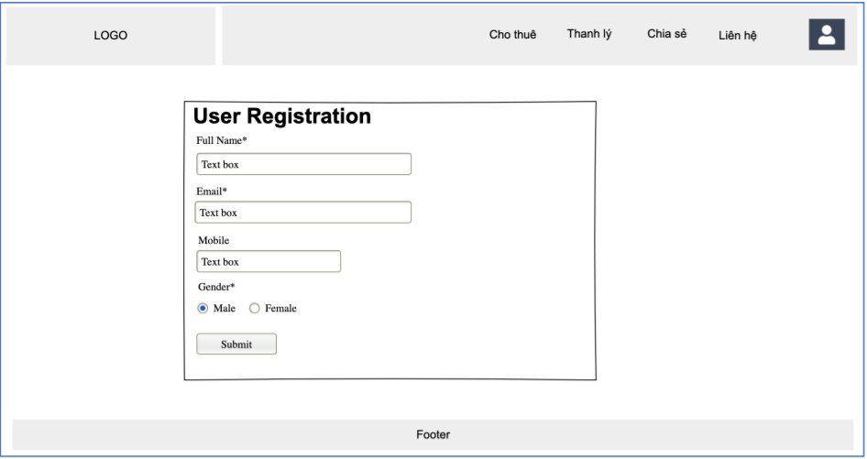

* Function details : Allows the user to register himself or herself to the system by inputting the following information: full name, gender, email, mobile. Users then need to verify by clicking the link sent via email to him/her before being able to access the system.

## 4. User Profile

* Function trigger: Homepage→ User profile(click on avatar at right top corner)
* Function description: Display all user’s information for data storage and contact
* Screen Layout:

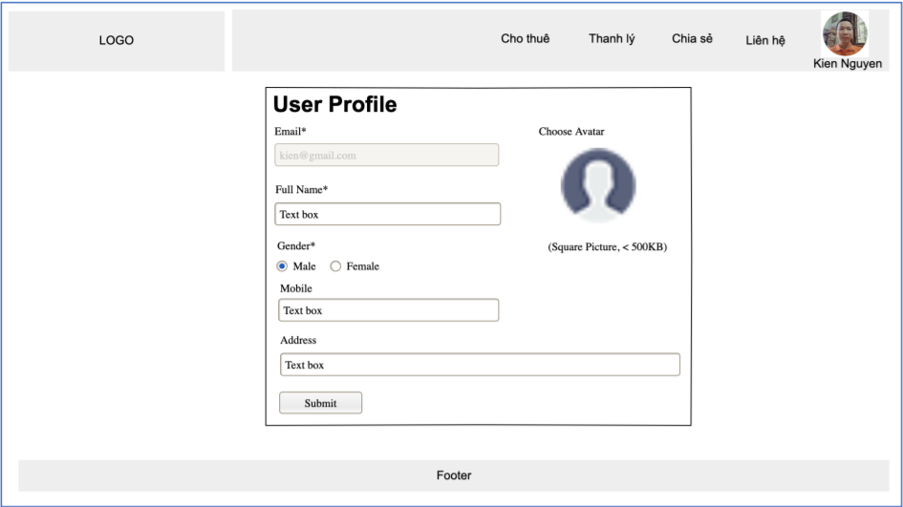

* Function details: Allows the user to view and edit his/her profile information, including the registered ones and the avatar image.

### Edit profile

* Function trigger: User profile -> Edit (click on Edit at right top corner)
* Function description: Display all user’s information for data storage and contact
* Screen Layout:



* Function details: Allows the user to edit his/her profile information, including the registered ones and the avatar image.

## 5. Admin Dashboard

* Function trigger: Homepage → Login as admin
* Function description: View all function and data related on admin’s role such as view service category, update, add user (staff, customer)
* Screen Layout:

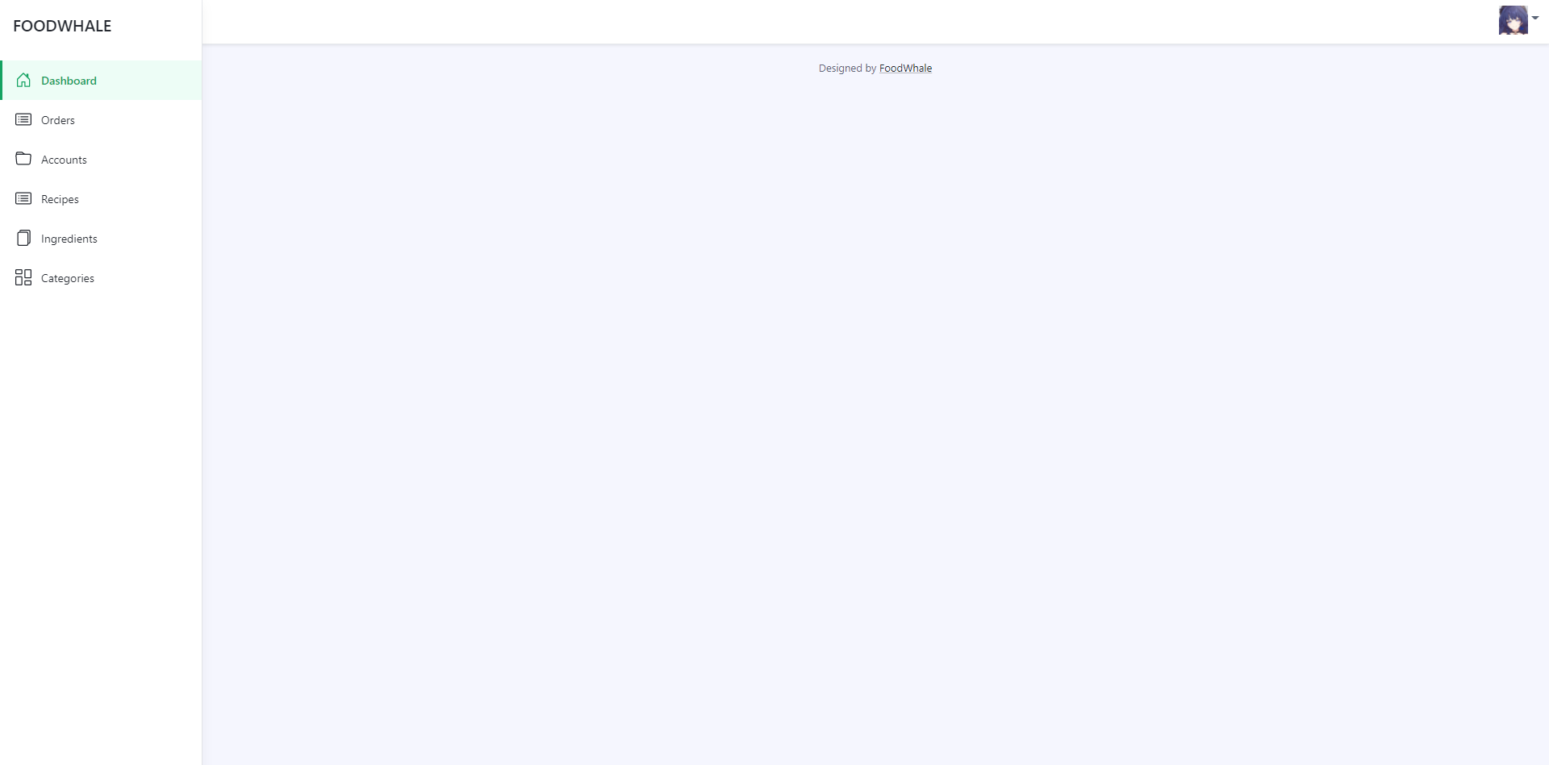

* Function details: Show the following:
* New orders (success, cancelled)
* View, update, add recipes list
* View, update, add ingredients list
* Control user (view users list and profile)

## 6. User Management

### User Lists

* Function trigger: HomePage -> Login As Admin -> Admin Dashboard -> User Management-->User List
* Function description: List, filter, search, show, hide, view, update. add new or edit existing user (staff, customer)
* Screen Layout:

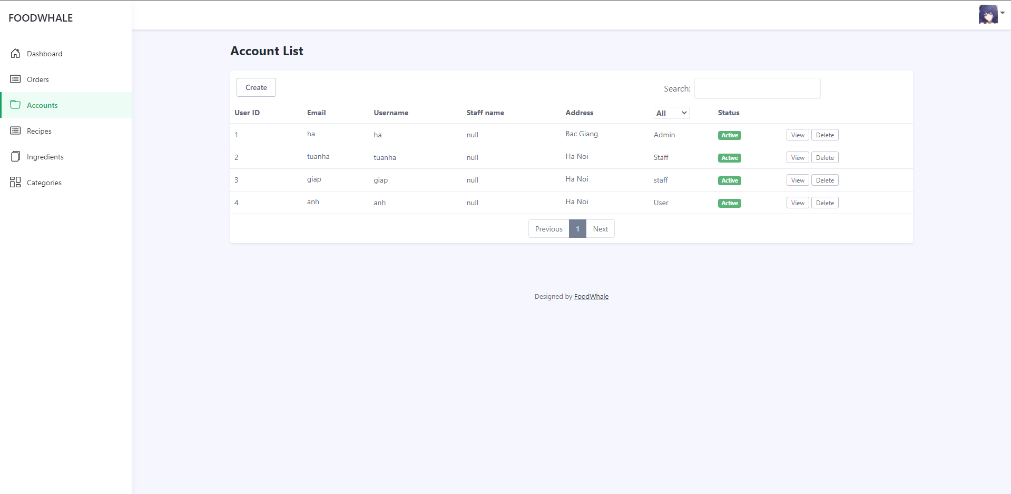

* Function details: Show the paginated list of registered users (include users' id, full name, gender, email, mobile, role, status):
* The admin can filter the users by gender, role, status
* Allow the admin to search users by full name, email, mobile
* The list is sortable by id, fullname, gender, email, mobile, role, status
* From each user, the admin can choose to view or edit user
* The page also have the button that allows the admin to add new user

### User Details

* Function trigger: HomePage -> Login As Admin -> Admin Dashboard -> User Management-->User List → User Details
* Function description: View and edit the details of a specific user
* Screen Layout:

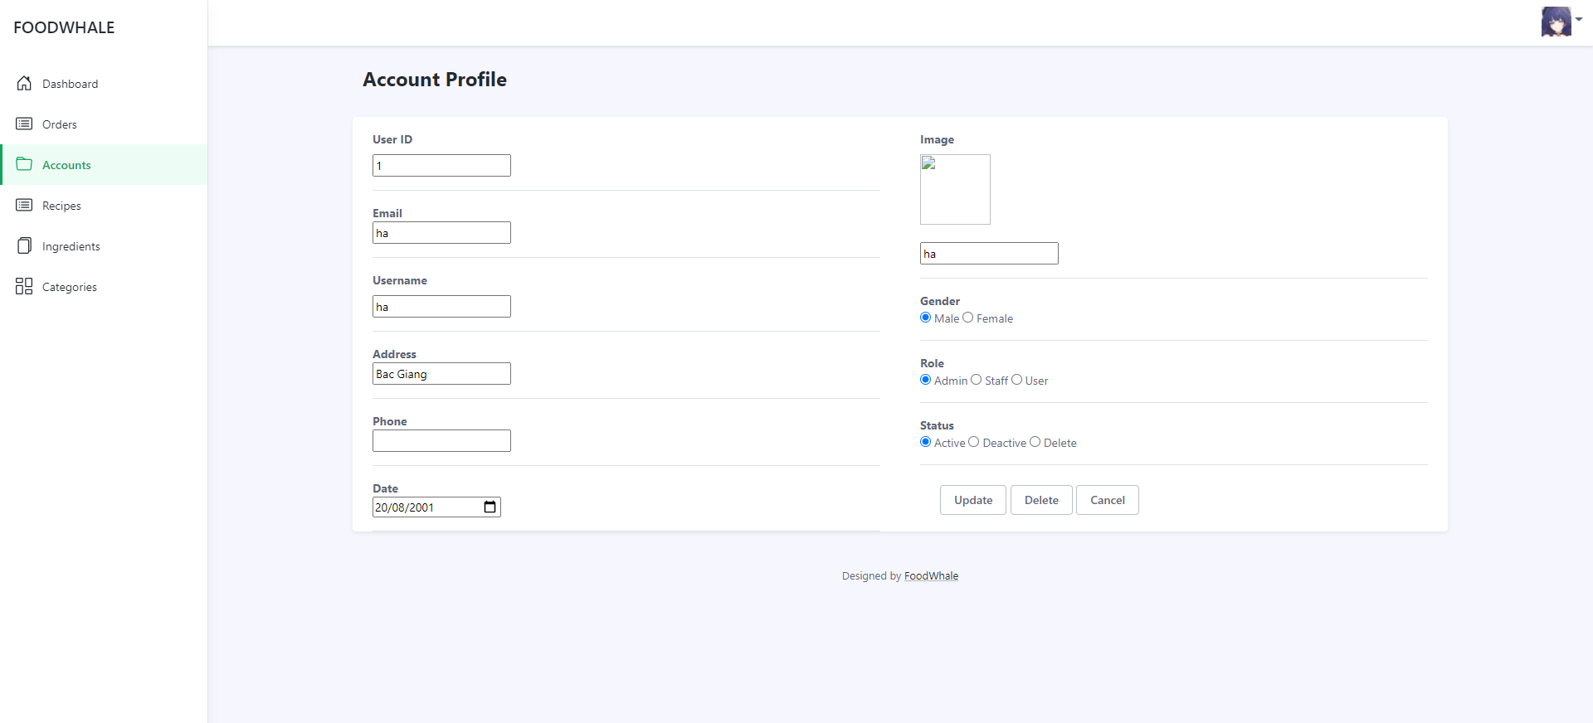

* Function details: Show detailed user information (avatar, full name, gender, email, mobile, role, address, status), from that allow the user to add new, view or edit user information

## 7. Reset Password

* Function trigger: Homepage→ Login→ Reset Password
* Function description: Users can reset their accounts’ password in case they forgot their password
* Screen Layout:

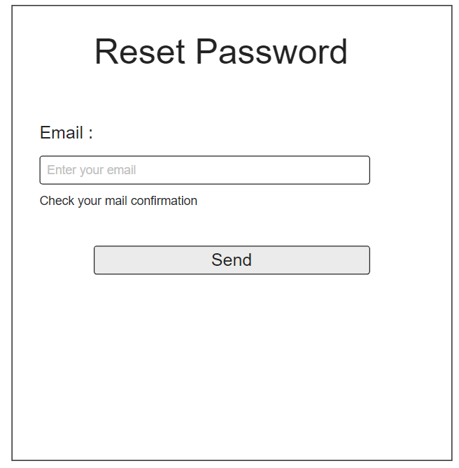

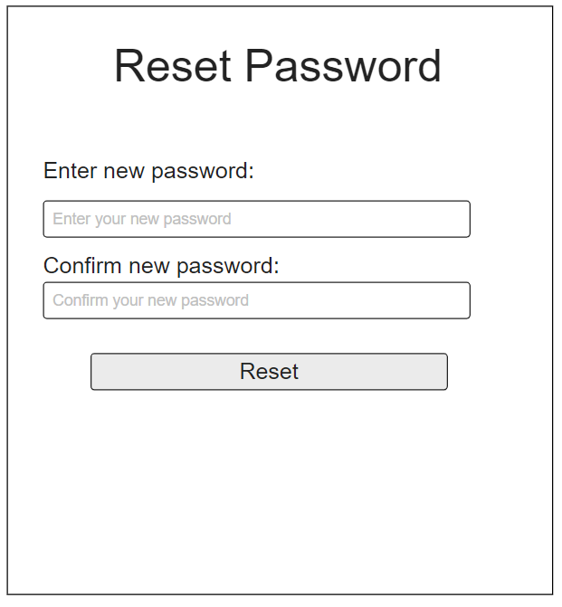

* Function details: The user input his/her email and username to receive the reset password code. The code is sent to the user’s email address . By entering the code , the user is redirected to the password resetting page in which she or he input a new password (and confirm password ).

## 8. Order Management

### Order Lists

* Function trigger: HomePage -> Login As Admin -> Admin Dashboard -> Order Management-->Order List
* Function description: List, filter, search, show, hide, view, update. add new or edit existing order (pending, done)
* Screen Layout:

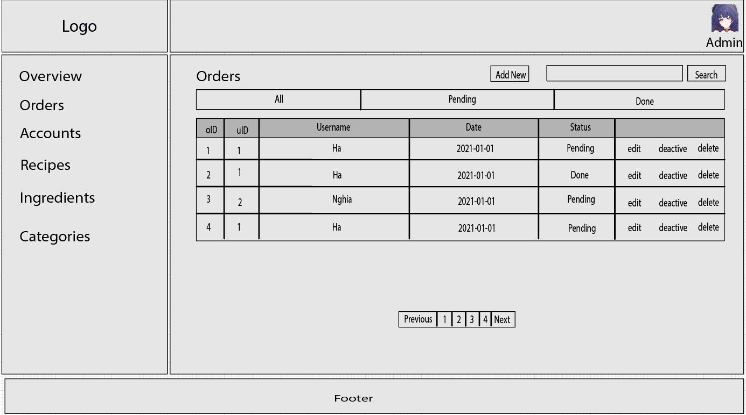

* Function details: Show the paginated list of all orders (include oid, uid, uname, date, status):
* The admin can filter the order by status
* Allow the admin to search order by uname, uid, date
* From each order, the admin can choose to edit, deatice or delete order
* The page also have the button that allows the admin to add new order

### Order Details

* Function trigger: HomePage -> Login As Admin -> Admin Dashboard -> Order Management-->Order List → OrderDetails
* Function description: View and edit the details of a specific user
* Screen Layout:

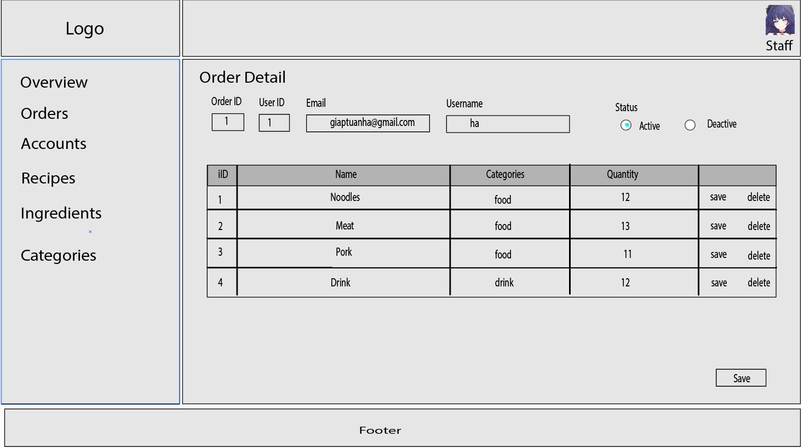

* Function details: Show detailed order information (order ID, user ID, email, username, status, address, status, ingredient ID, ingredient Name, ingredient categories, quantity), from that allow the user to add new, view or edit order information

## 9. Customer Management

### Customer Lists

* Function trigger: HomePage -> Login As Staff -> Staff Dashboard -> Customer Management-->Customer List
* Function description: List, filter, search, show, hide, view, update. add new or edit existing user (active, deactive)
* Screen Layout:

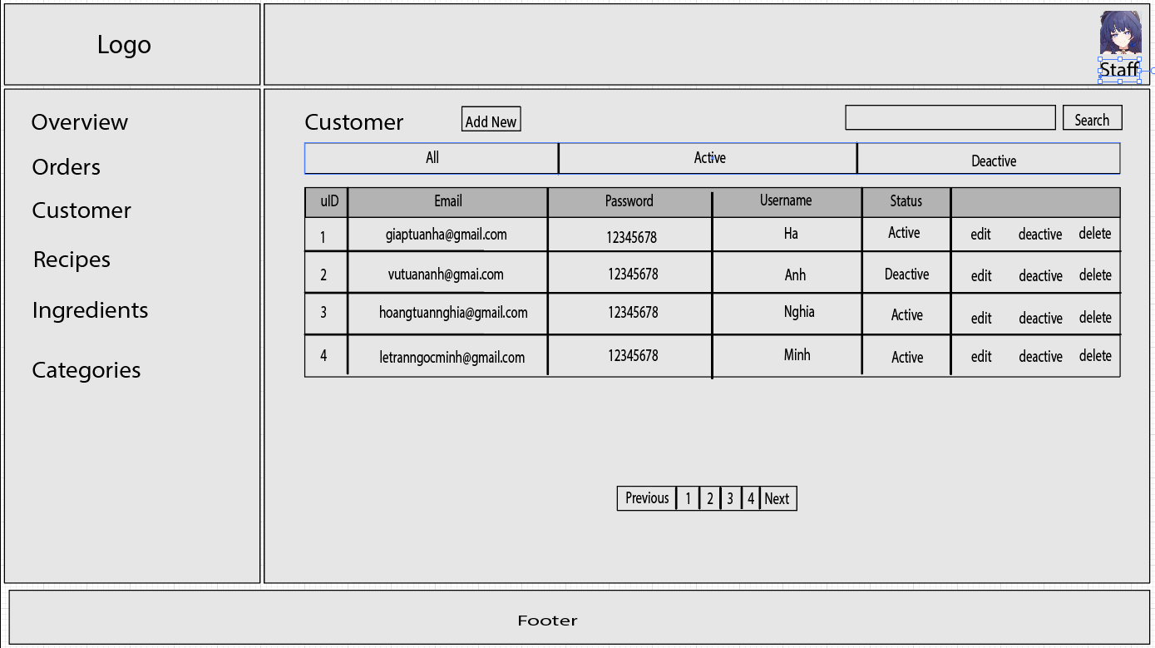

* Function details: Show the paginated list of all user who is User (include users' id, email, password, username, status):
* The staff can filter the order by status
* Allow the staff to search user by email, username, phone
* From each order, the staff can choose to view or edit user
* The page also have the button that allows the staff to add new user

### Customer Details

* Function trigger: HomePage -> Login As Staff-> Staff Dashboard -> Customer Management-->Customer List → CustomerDetails
* Function description: View and edit the details of a specific user
* Screen Layout:

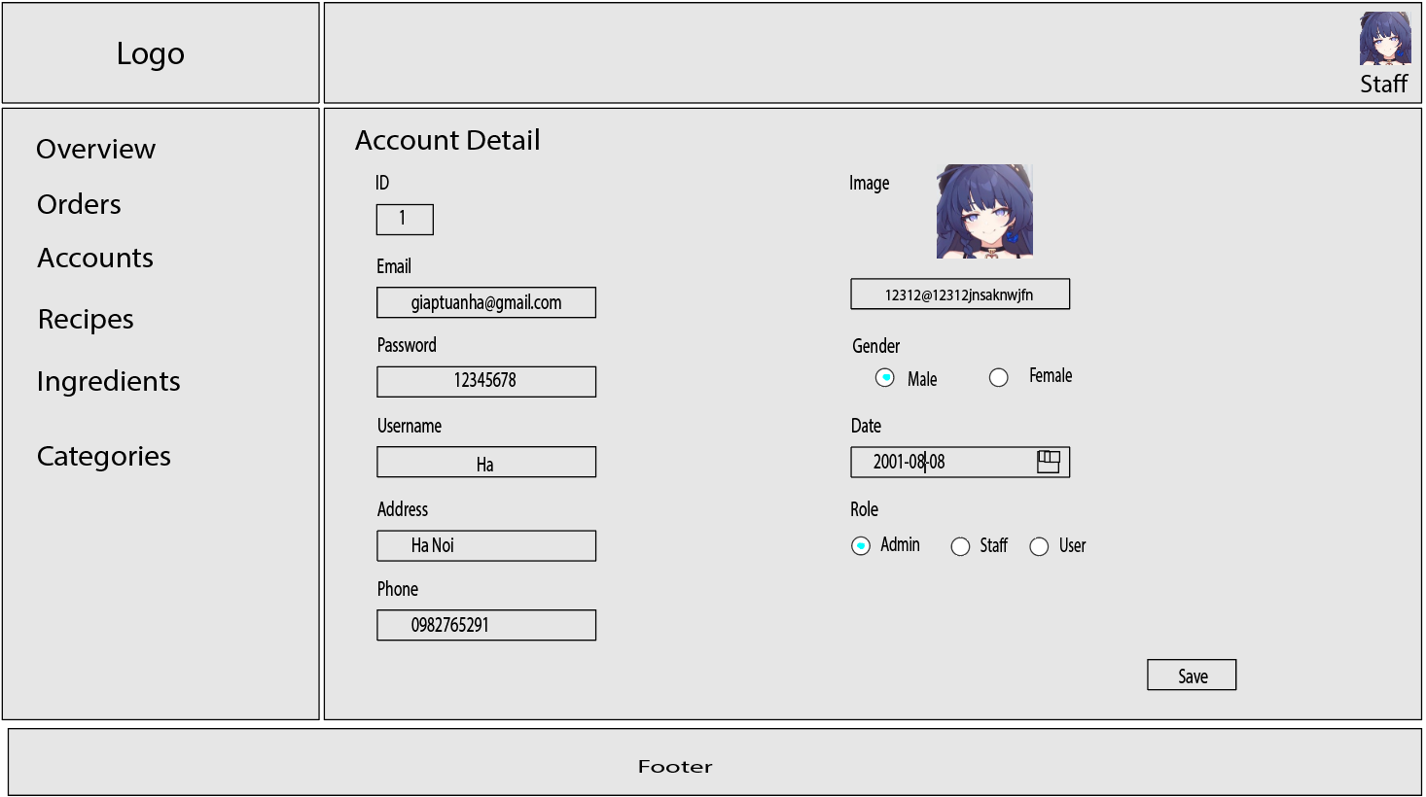

* Function details: Show detailed user information ( users' id, email, password, username, avatar, gender, email, phone, status), from that allow the staff to add new, view or edit user information

## 10. Recipe Management

### Recipe Lists

* Function trigger: HomePage -> Login As Admin/Staff -> Staff Dashboard -> Recipe List
* Function description: List of all Recipe from database, can search, create, edit, delete, or filter
* Screen Layout: 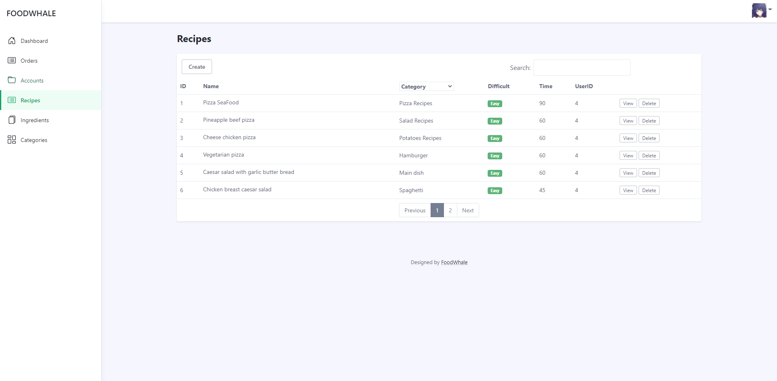
* Function details: Show all the Recipes in database
* can filter the Recipes by Category
* search Recipes by name or type
* can choose to edit, delete or create new Recipes

### Recipe Details

* Function trigger: HomePage -> Login As Admin/Staff -> Staff Dashboard -> Recipe List→ RecipeDetails
* Function description: View and edit the details of a specific Recipe
* Screen Layout:

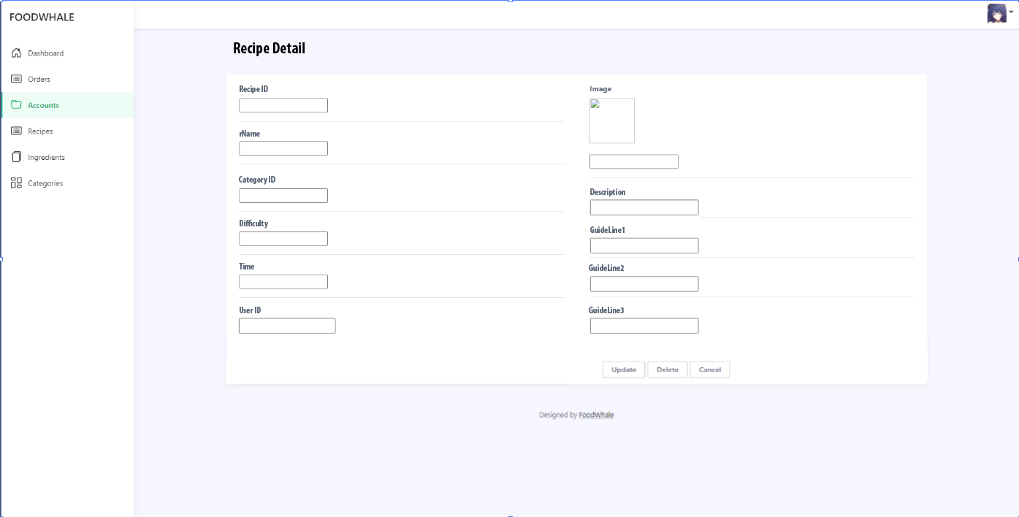

* Function details: Show detailed Recipe information ( recipe name, category ID, Image, Difficulty, Time, uID, rDescription, Guideline1, Guideline2, Guideline3), from that allow the admin/staff to add new, view or edit Recipe information

### Recipe Ingredient Link

* Function trigger: HomePage -> Login As Admin/Staff -> Staff Dashboard -> Recipe List→ RecipeDetails → RecipeIngredient
* Function description: View and edit the Recipe Ingredient of a specific Recipe
* Screen Layout:

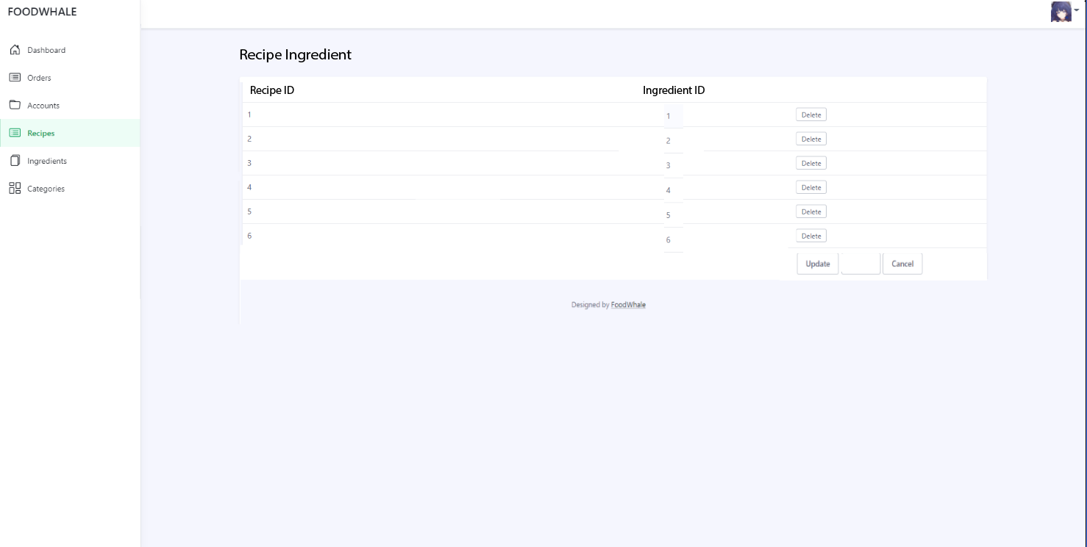

* Function details: Show detailed Recipe Ingredient( recipe ID, Ingredient ID), from that allow the admin/staff to add new, view or edit Recipe Ingredient

## 11. View Recipe

### When user has not logged in

* Function trigger: When a user accesses the website.
* Function description: show recipes, featured services and static contact links.
* Screen Layout:

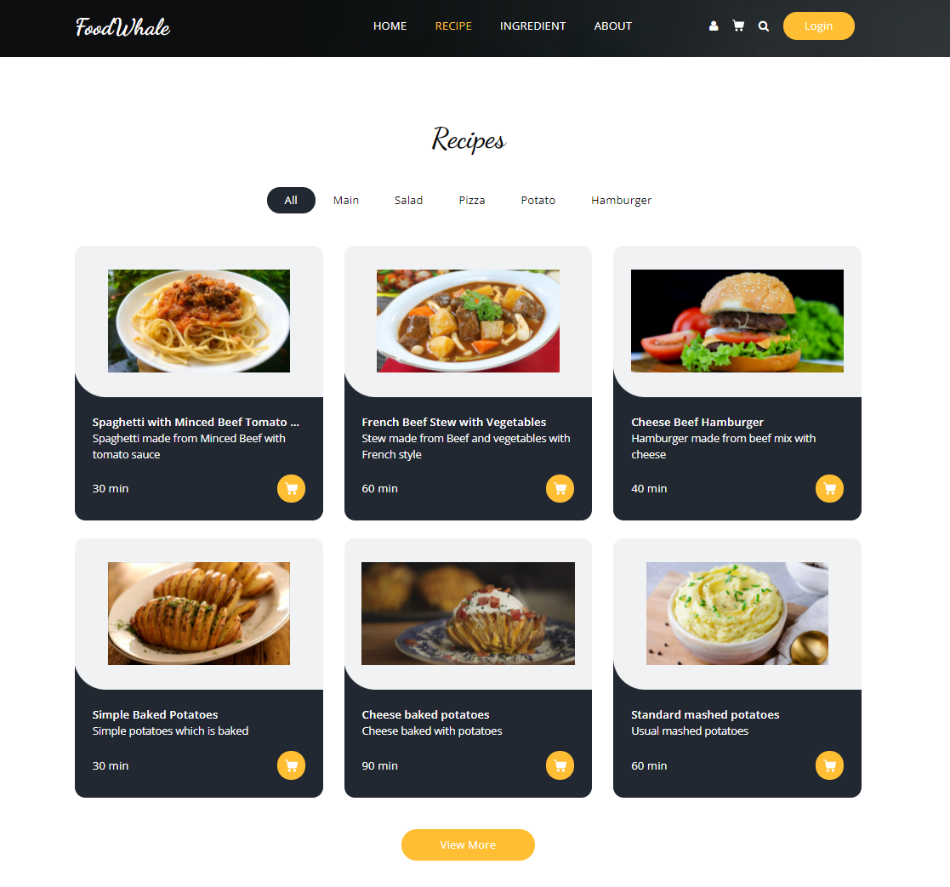

* Function details: Users can see the Recipes list , detailed information about the recipes , view ingredients list , and users can login by clicking on the login button.

### When user has logged in

* Function trigger: Homepage → Login as Customer
* Function description: show sliders ,hot posts, featured services and static contact links.
* Screen Layout:

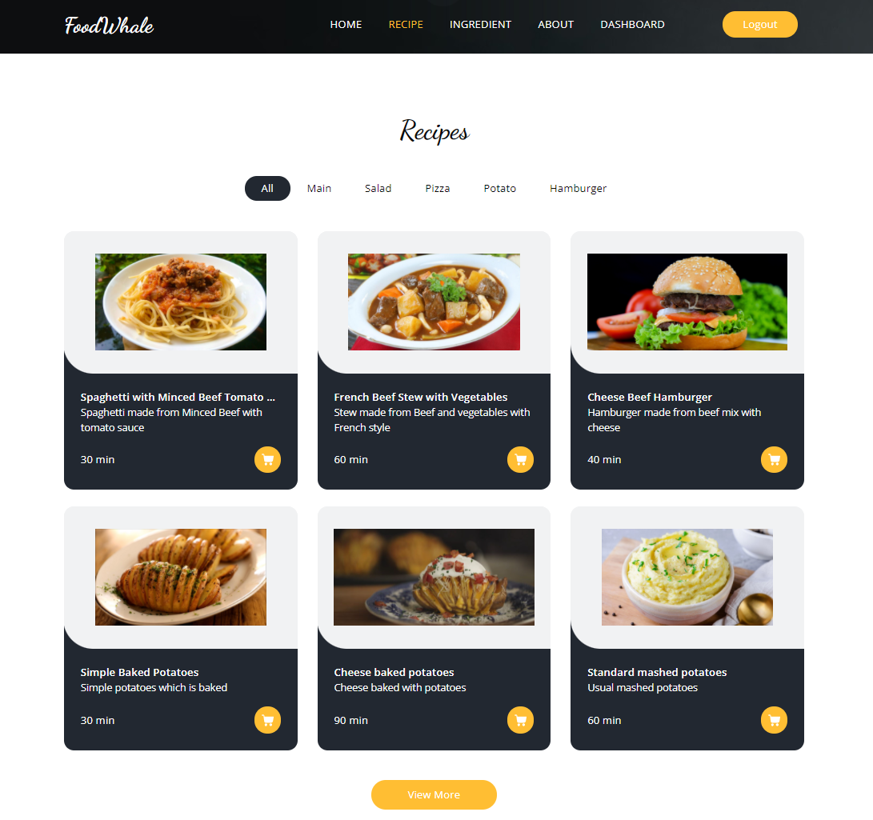

* Function details : Users can see recipes list and can add ingredients of the recipe to cart and create new orders for the ingredients

## 12. View Ingredients

### When user has not logged in

* Function trigger: When a user accesses the website.
* Function description: show ingredients, featured services and static contact links.
* Screen Layout:

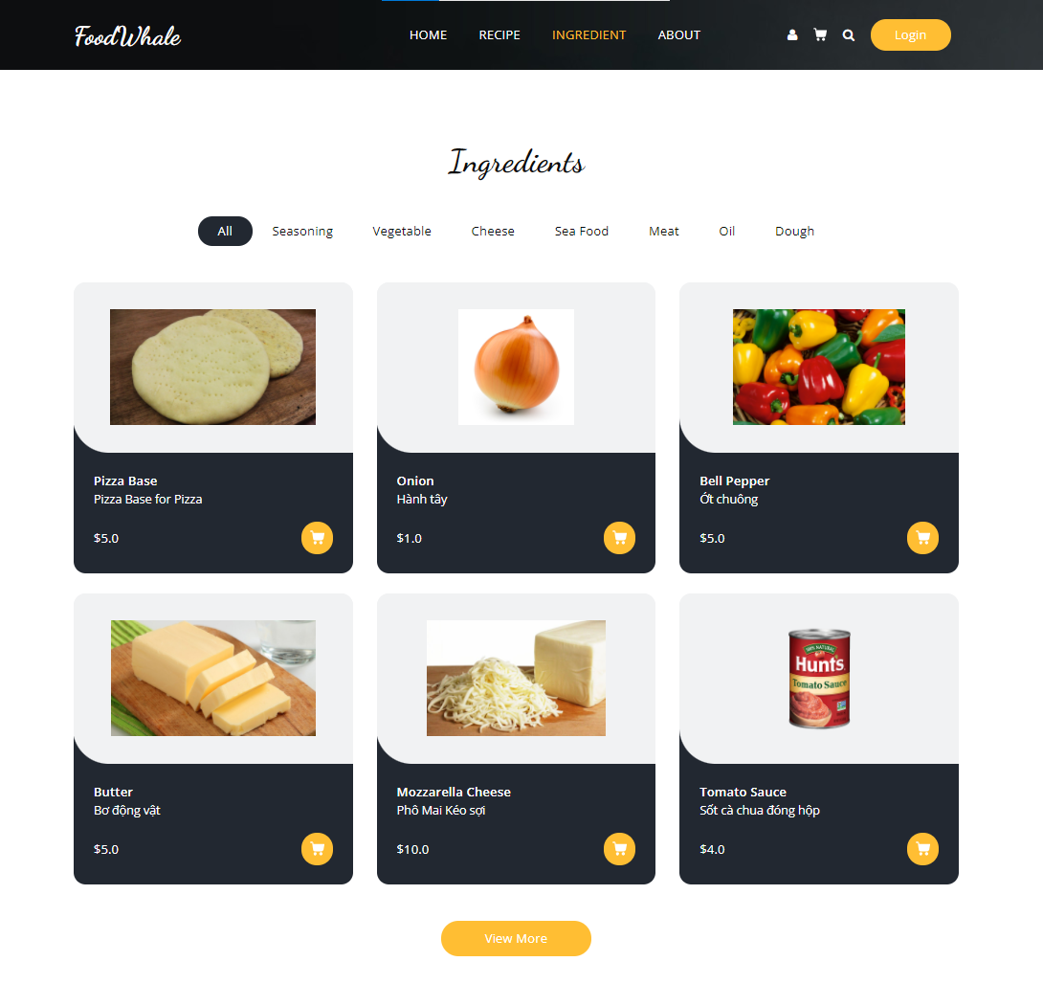

* Function details: Users can see the Ingredients list , detailed information about the recipes , view ingredients list , and users can login by clicking on the login button.

### When user has logged in

* Function trigger: Homepage → Login as Customer
* Function description: show ingredients, featured services and static contact links.
* Screen Layout:

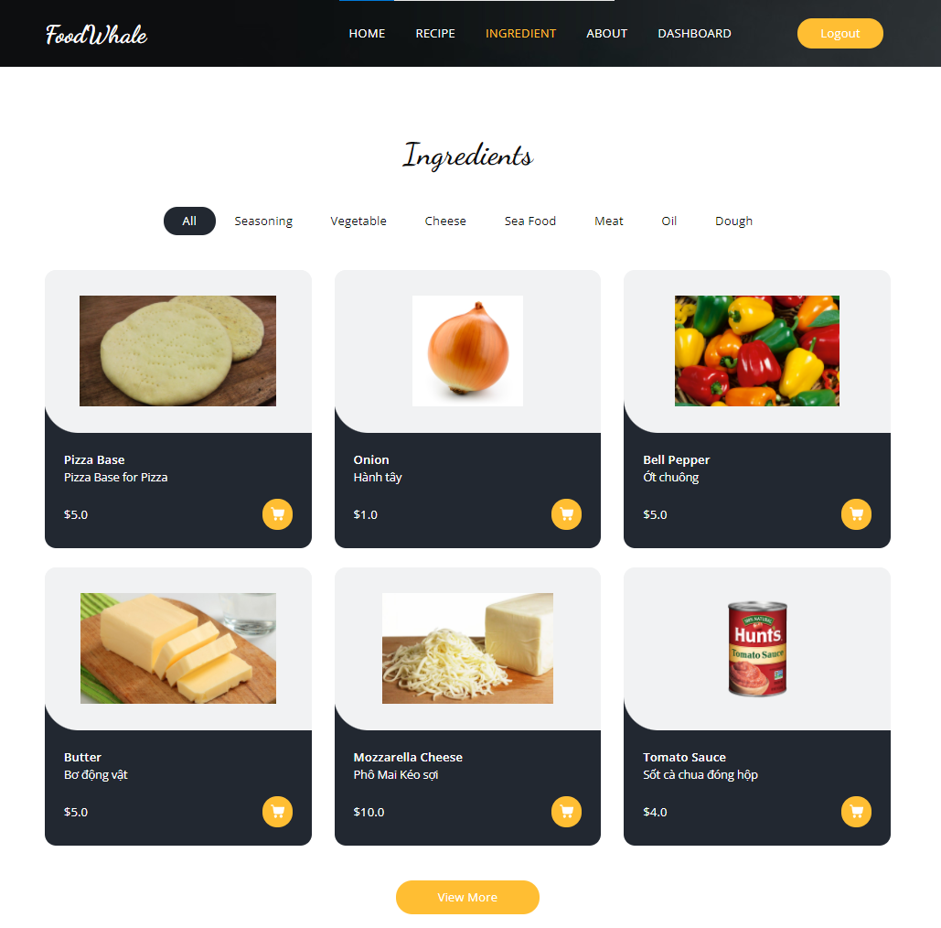

* Function details : Users can see ingredients list and can add ingredients to cart and create new orders for the ingredients

## 13. Add to cart

* Function trigger: When a user accesses the website and click on add to cart.
* Function description: Add Ingredient to Cart.
* Screen Layout:

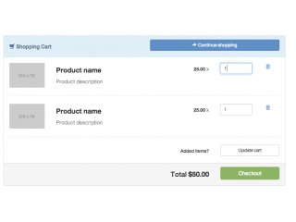

* Function details: Users can see the Ingredients , users can add to cart by clicking on the add to cart button.

## 14. Post Recipe

* Function trigger : Homepage→ Login as customer→ Post recipe
* Function description: Users can post their own recipe to the system to share with other users.
* Screen Layout:

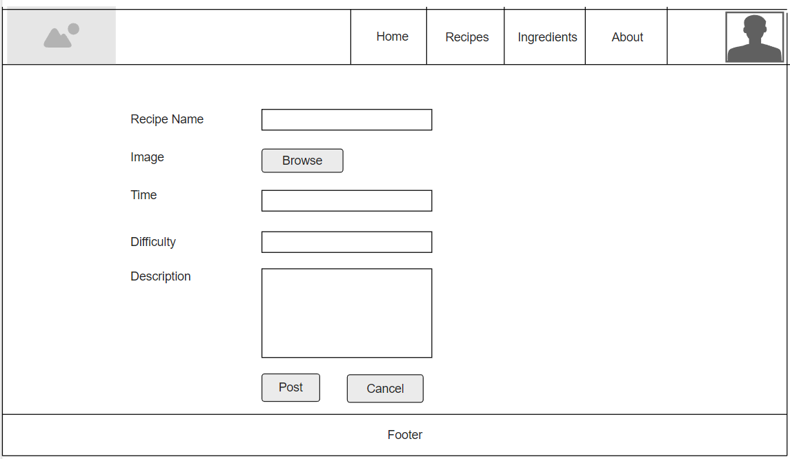

* Function details: When users click on the “Post Recipe” button , there will be input fields for users to enter the recipe name , difficulty of the recipe , time necessary to finish , and steps to make the dish. After clicking the “post” button , the recipe will be added to the database . Users can click on the “Cancel” button to go back to the homepage.

## 15. View liked recipes

* Function trigger: Homepage→Login as customer→ click on the avatar→ view liked recipes
* Function description: Display the recipes that users have added to favourite list
* Screen layout:

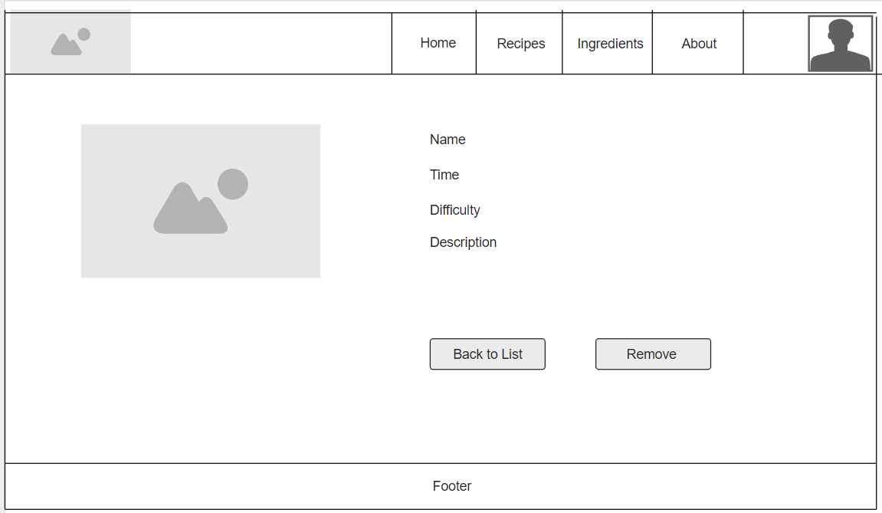

* Function details: Users can view their favourite recipes and can also remove one from the list by clicking on the “remove ” button.

## 16. View Recipe Detail

* Function trigger: Homepage → View Recipe → View Recipe Detail
* Function description: Display image, name, difficulty, ingredients, description, shopping options of a Recipe when the user clicks on a Recipe in View Recipe.
* Screen Layout:

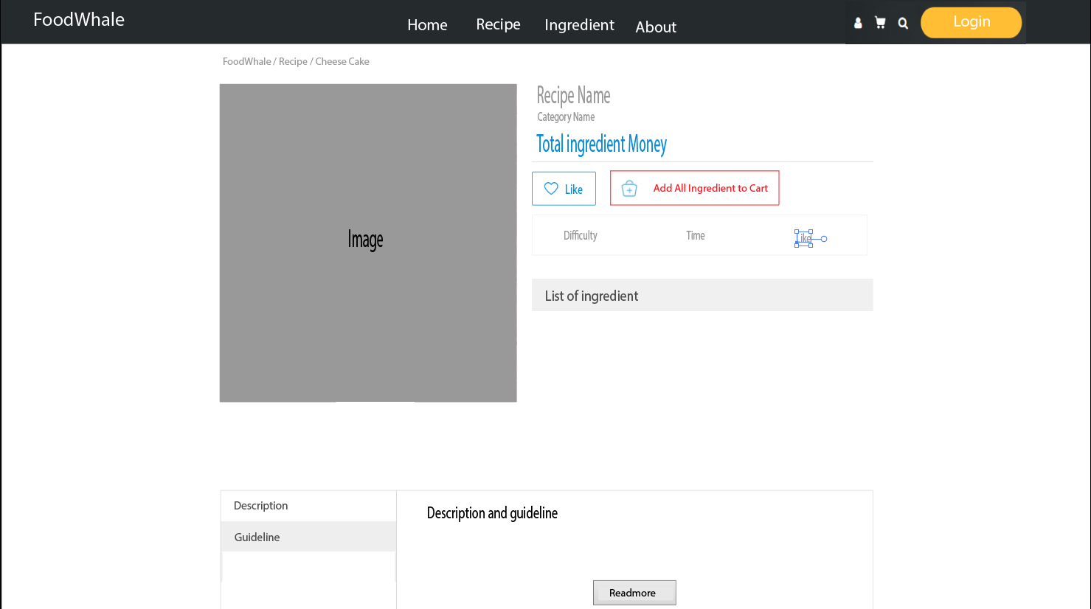

* Function details:
* Show the details of that Ingredient (Image, Name, Category, Price of all Ingredients, Difficulty, Time, Like count, List of Ingredients, Description, Guideline).
* The “Read More” button will show all information of Description/Guideline.
* When User has not logged in
* The “Add to Cart” button will redirect the user to the Login page.
* When User has logged in
* The “Add to Cart” button will add all the Ingredients of that Recipe to the User's Cart.

## 17. View Ingredient Detail

* Function trigger: Homepage → View Recipe → View Recipe Detail
* Function description: Display image, name, price, type, description, shopping options of an Ingredient when the user clicks on a Recipe in View Recipe.
* Screen Layout:

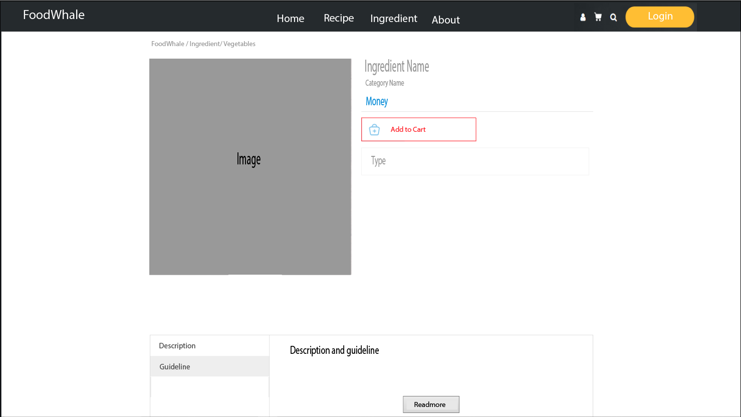

* Function details:
* Show the details of that Ingredient (Image, Name, Category, Price, Type, Description, Guideline).
* The “Read More” button will show all information of Description/Guideline.
* When User has not logged in
* The “Add to Cart” button will redirect the user to the Login page.
* When User has logged in
* The “Add to Cart” button will add that Ingredient to the User's Cart.

## 18. Ingredient Management

### Ingredient Lists

* Function trigger: HomePage -> Login As Staff/Admin-> Staff/Admin Dashboard -> Ingredient List
* Function description: List of all Ingredients from database, can search, create, edit, delete, or filter
* Screen Layout:

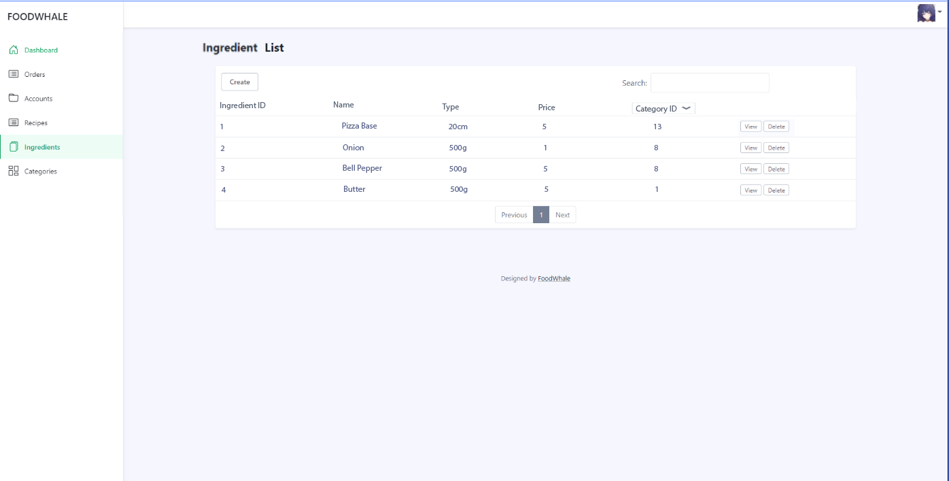

* Function details: Show all the Ingredients in database
* can filter the Ingredient by status
* search Ingredient by name or type
* can choose to edit, delete or create new Ingredient

### Ingredient Details

* Function trigger: HomePage -> Login As Staff/Admin-> Staff/Admin Dashboard -> Ingredient List -> Ingredient Detail
* Function description: View and edit the details of a specific Ingredient.
* Screen Layout:

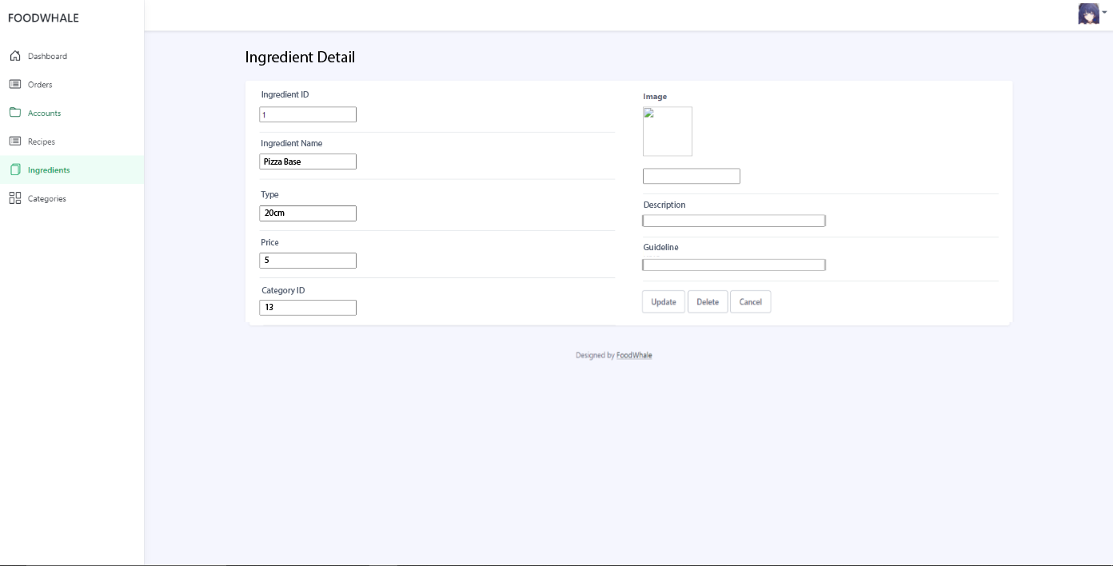

* Function details: Show detailed Ingredient information ( ingredient id, inName, type, price, category ID, image, description, guideline), from that allow the staff to add new, view or edit Ingredient information

## 19. Category Management

### Category Lists

* Function trigger: HomePage -> Login As Staff/Admin -> Staff/Admin Dashboard -> Category List
* Function description: List of all Category from database, can search, create, edit, delete
* Screen Layout:

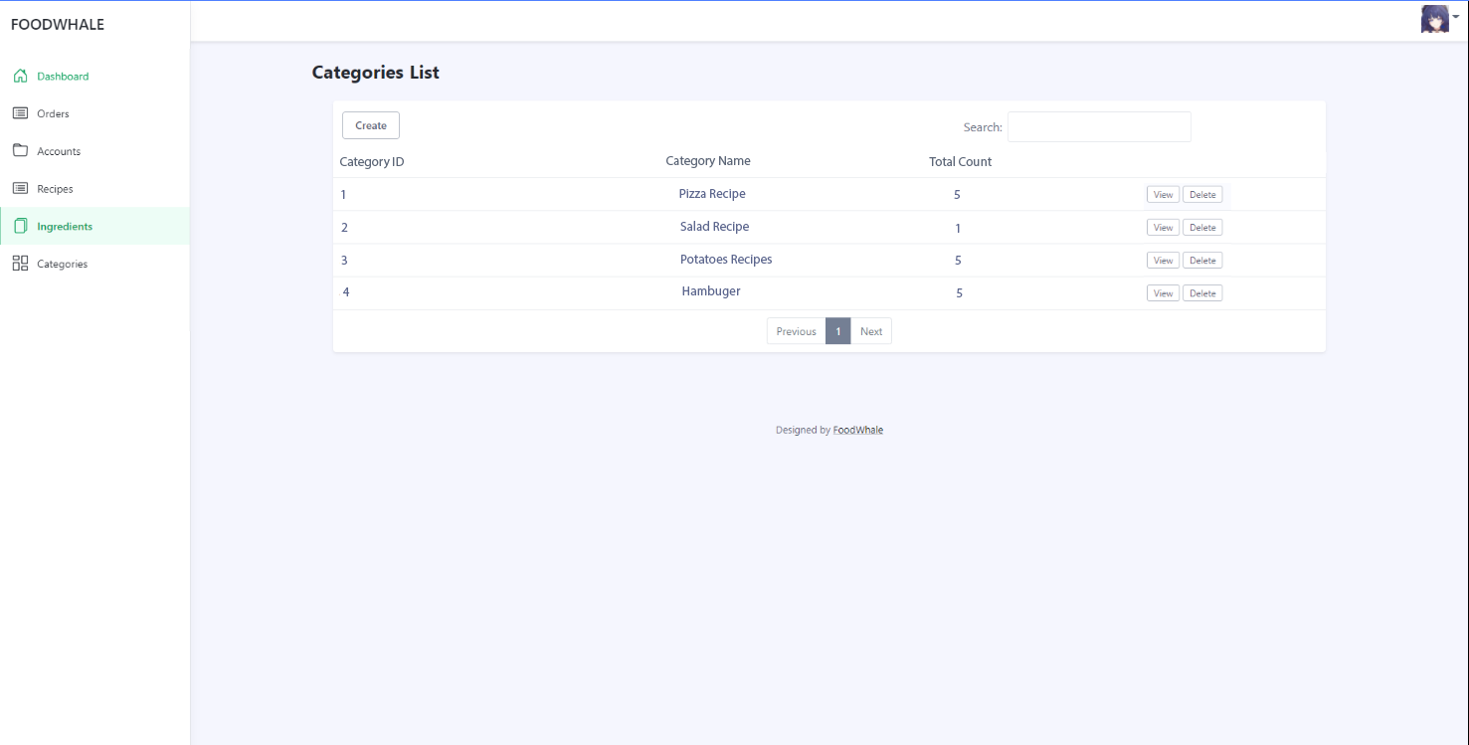

* Function details: Users can view their favourite recipes and can also remove one from the list by clicking on the “remove ” button.

### Category Details

* Function trigger: HomePage -> Login As Staff/Admin -> Staff/Admin Dashboard -> Category List -> Category Detail
* Function description: View and edit the details of a specific Category.
* Screen Layout:

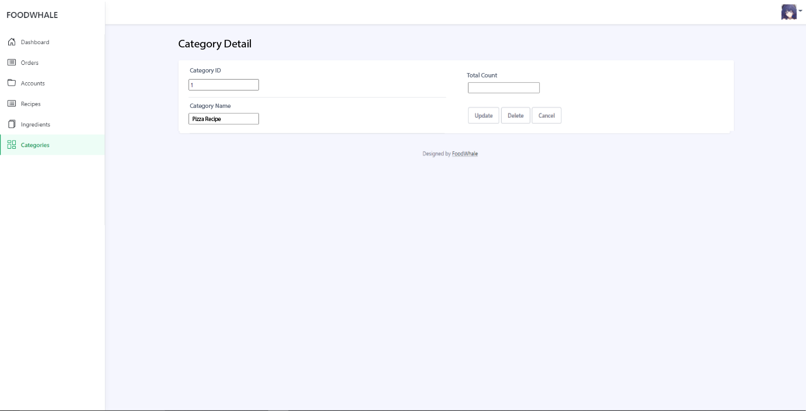

* Function details: Show detailed Category information (Category id, Category Name, total count), from that allow the staff to add new, view or edit Category information

## 20. Change Password

* Function trigger: Homepage→ Login→ ChangePassword
* Function description: Users can change their accounts’ password in case they want a new password
* Screen Layout:
* 
* Function details: The user input his/her email and Password to change the Passord.

## 21. User order history

* Function trigger : Homepage→ Login as customer→ Orders History
* Function description: Users can view their orders history to see what they have bought in the past.
* Screen Layout:

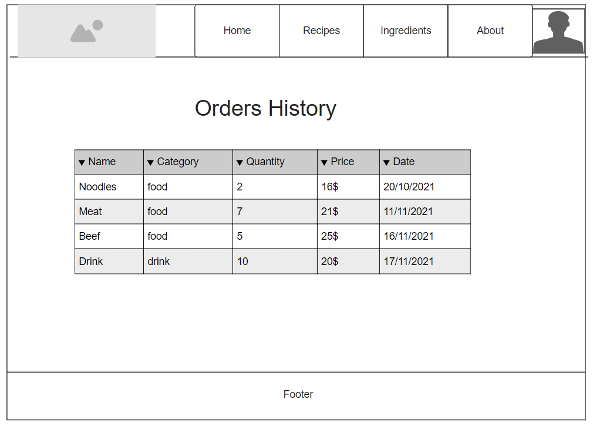

* Function details: Users can see the information about the products they have purchased include : product name, category, quantity , price and the time they have purchased the product

## 22. User Favourite Recipe management

* Function trigger :
  + Remove : Homepage→ Login as customer→ Favourite Recipes → Remove
  + Add new : Homepage→Login as customer→ View recipes → Add to favourite list
* Function description: Users can add a recipe to their favourite list or remove it from their favourite list.
* Screen Layout:

-Add new:



-Remove:



* Function details: When users click on the ”like '' button on the recipe details page ,the information about that recipe will be added to the user's favourite list . If users want to remove them from the list , they can click on the “remove” button in the favourite recipes page.

## 23. Cart Detail

* Function trigger: Homepage → Login → Cart Detail
* Function description: Display image, name, price, type, quantity, sub total and action delete.
* Screen Layout:

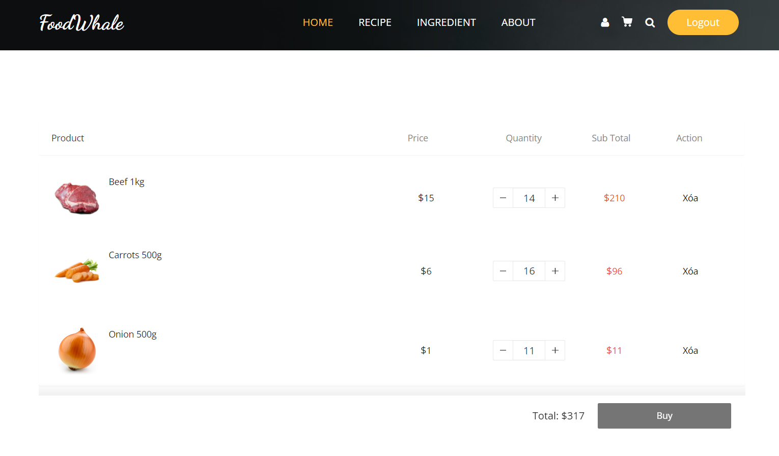

* Function details:
* Show the details of that Order ( image, name, price, type, quantity, sub total).
* The “+” button will increase by one unit.
* The “-” button will increase by one unit.
* The “Xoa” button will delete the ingredient from cart.
* The “Buy” button will change the status of the present cart to “Waiting” and create new Cart for User.

## 24. Contact page

* Function trigger: Homepage → ContactPage → View Recipe Detail
* Function description: Display image, name, price, type, description, shopping options of an Ingredient when the user clicks on a Recipe in View Recipe.
* Screen Layout:
* 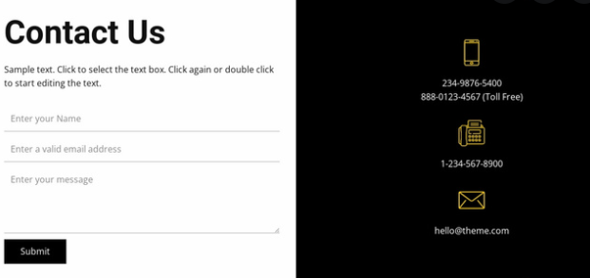
* Function details:
* Show the form for user to contact.

## 25.Error Page:

* Function trigger: Any pages that are losing connection.
* Function description: Display an screen with a notification to users that some problems happens so user can click back to the home page.
* Screen Layout:

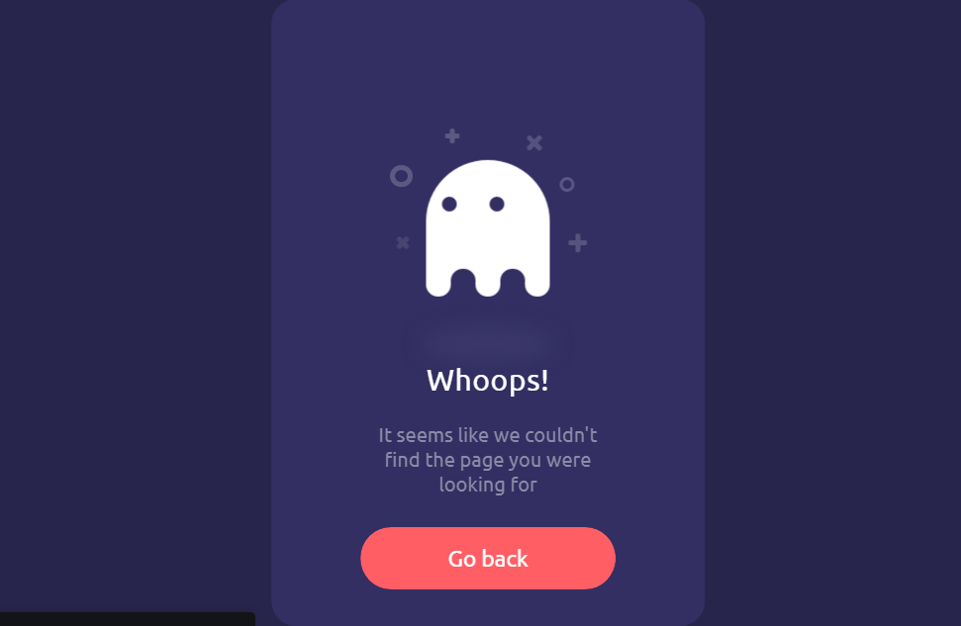

## 26.Share Page:

* Function trigger: Homepage → Recipe → Recipe Detail -> Share.
* Function description: Copy URL of the recipe detail that users choose for sharing recipe information to their community on Facebook.
* Screen Layout:

